# Day 2 - Logon Script GPO

**Write `welcome.ps1`**
Write-Host "Welcome to KaraboNode, $env:USERNAME"

**Copy it into the SYSVOL scripts folder**
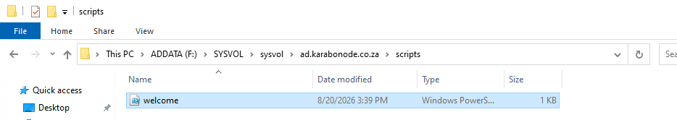
**Create a new GPO**
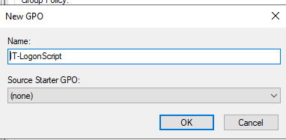
**Link it to the IT OU**
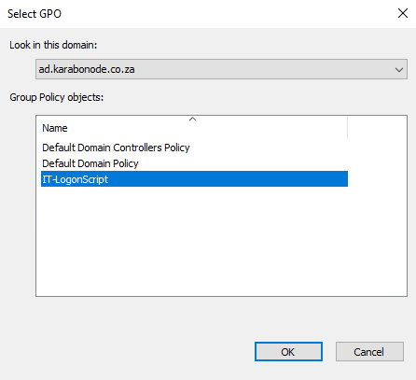
**Assign the script.**
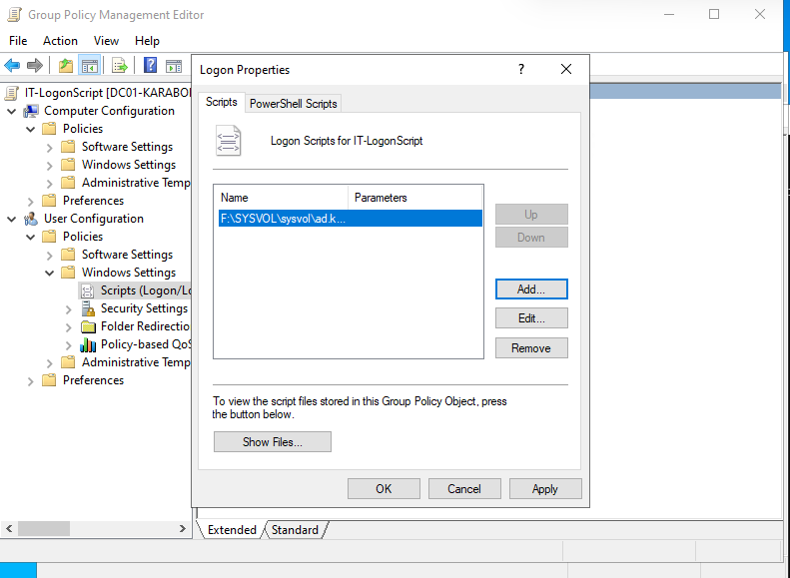
## Why this matters
Demonstrates SYSVOL/DFSR replication and GPO linking mechanics.

## Skills covered
SYSVOL script placement and DFSR replication awareness, GPO creation and OU-scoped linking, logon script assignment through User Configuration policy.

